

**TALLER VACIONAL GRADO TECERO (3°) SOCIALES DOCENTE: MARGARITA MEJIA VARGAS**

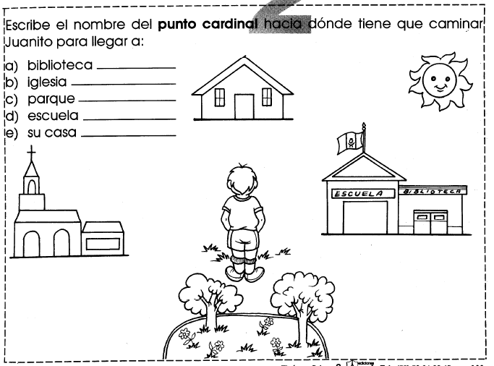



**TALLER VACACIONAL GRADO TECERO (3°) SOCIALES DOCENTE: MARGARITA MEJIA V**

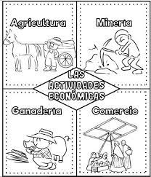

**ACTIVIDAD:**

Colorea y luego escribe las características que tiene cada actividad económica del hombre y sus clasificaciones:

________________________________________________________________________________________________________________________________________________________________________________

________________________________________________________________________________________________________________________________________________________________________________

________________________________________________________________________________________________________________________________________________________________________________

________________________________________________________________________________________________________________________________________________________________________________

________________________________________________________________________________________________________________________________________________________________________________

________________________________________________________________________________________________________________________________________________________________________________

______________________________________________



**TALLER VACACIONAL GRADO TECERO (3°) SOCIALES DOCENTE: MARGARITA MEJIA V**

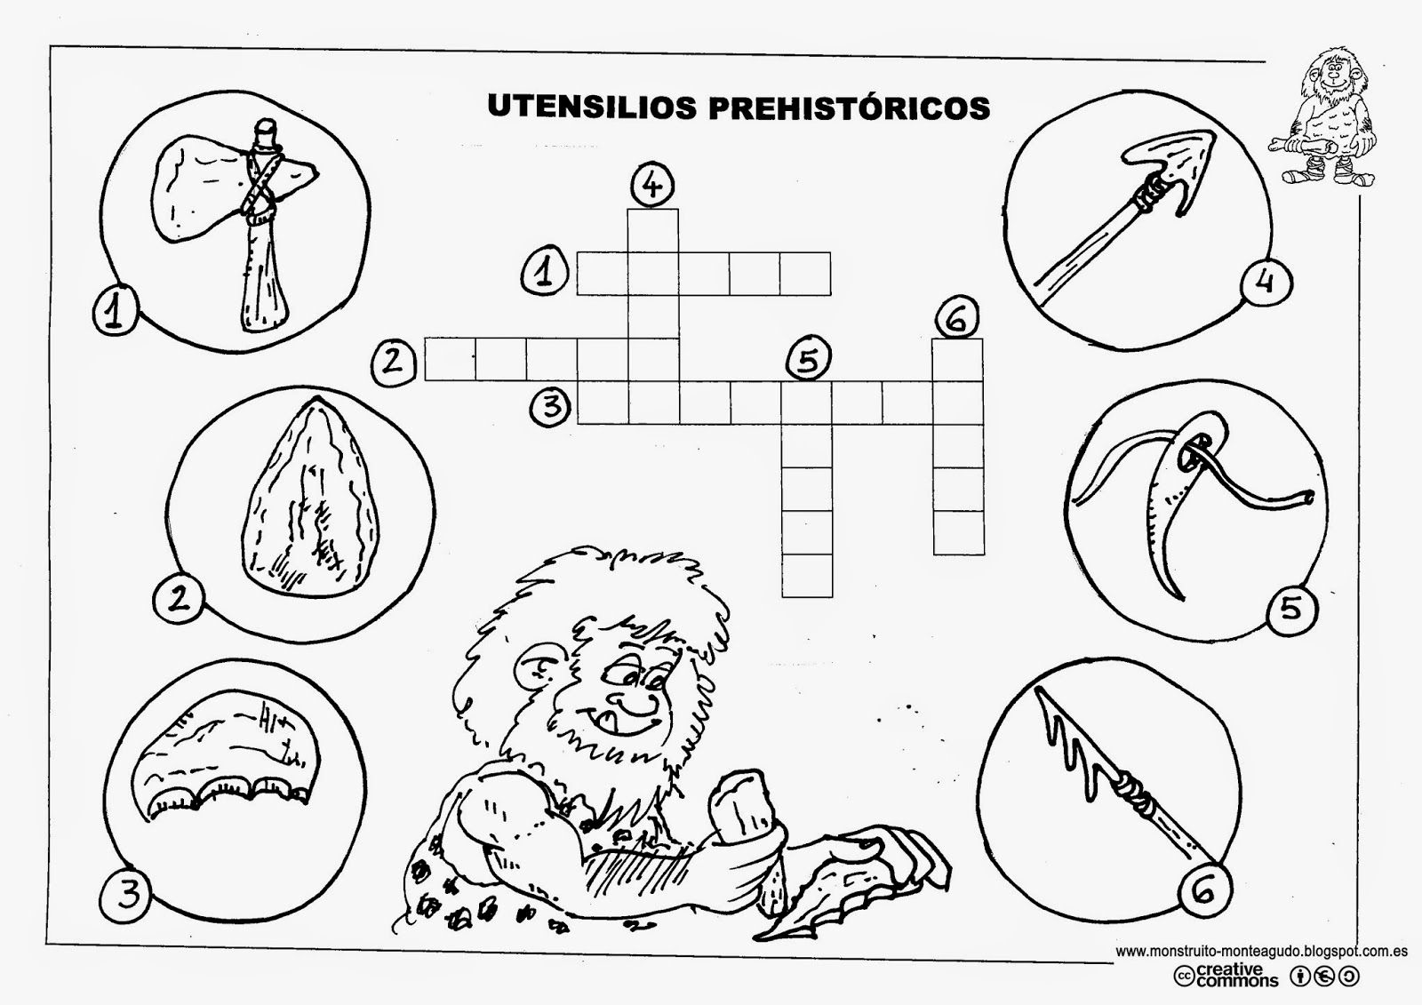

**ACTIVIDAD: PRIMERO COLOREA Y LUEGO RECUERDA LOS NOMBRES DE ESTOS UTENCILIOS PREHISTORICOS PARA QUE PUEDAS REALIZAR EL CRUCIGRAMA**



**TALLER VACACIONAL GRADO TECERO (3°) SOCIALES DOCENTE: MARGARITA MEJIA V**

**ACTIVIDAD:**

Colorea, luego realiza el crucigrama y por ultimo escribe algunas estrofas del Himno Nacional de Colombia:

________________________________________________________________________________________________________________________________________________________________________

________________________________________________________________________________________________________________________________________________________________________

________________________________________________________________________________________________________________________________________________________________________

________________________________________________________________________________________________________________________________________________________________________

________________________________________________________________________________________________________________________________________________________________________

__________________________________________________________________________________________________________________________________________________________________________________________________________________

______________________________________________

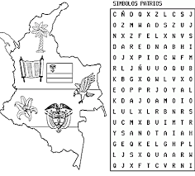



**TALLER VACACIONAL GRADO TECERO (3°) SOCIALES DOCENTE: MARGARITA MEJIA V**

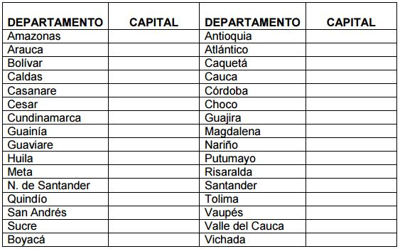

**ACTIVIDAD:** Investiga la capital de cada departamento y al respaldo de la hoja dibuja el mapa de Colombia con su división política.