MATH
GRADO 5°

TALLER DE VACACIONES

Answer the following questions according to the number 745.89

1. Which number is in the hundreds place?
A. 7
B. 6
C. 4
D. 9

2. Which number is in the hundredths place?
A. 5
B. 7
C. 8
D. 9

3. Number 5 is in the…
A. ones place.
B. tenths place.
C. tens place.
D. hundreds place.

4. Number 8 is in the…
A. tens place.
B. tenths place.
C. ones place.
D. hundredths place.

5. How many squares can you see in the picture?

6. How many triangles can you see in the picture?

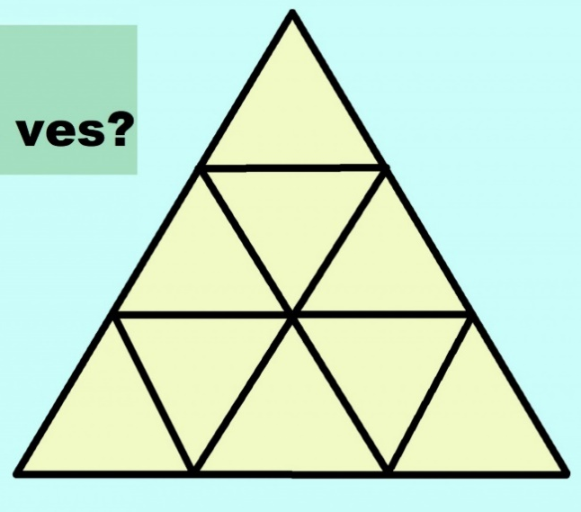

7. What is a ratio?
A. A ratio is a natural number
B. A ratio is a fraction
C. A ratio is an ordered pair of numbers a and b, written a / b where b does not equal 0
D. A ratio is a power to which a given number or expression is to be raised

8. What is the ratio of spiders to ladybugs?

9. What is the ratio of books to pens?

10. What is the ratio of lettuces to tomatoes?

11. What is the ratio of chairs to tables?

12. Complete the following Pascal’s Triangle

