MATH
GRADO 2°

TALLER DE VACACIONES

Answer the questions

- Daniel raked 45 brown leaves, 71 orange leaves and 53 yellow leaves in his front yard. How many leaves did he rake all together?
- 169
- 170
- 158
- 168

- Alice bought 300 sheets of lined paper for the school year. If she used 64 sheets during the first month, how many sheets does she have left?
- 45
- 46
- 47
- 48

- Solve the following subtraction problems. Subtract the numbers.

- Solve the following addition problems. Add the numbers.

- Write the symbol that makes the problem true. ≥ or ≤ or =
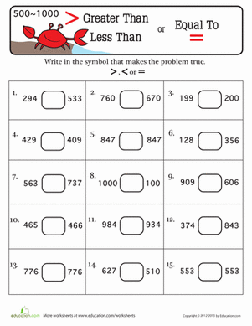

- Andrea is watching snowflakes fall. She notices that every snowflake has 6 points. If she catches 7 snowflakes in her hand, how many points does she catch altogether?
- 43
- 44
- 42
- 48

- Jesse is teaching snowboarding lessons to 4 different groups today. If there are 8 kids in each group, how many kids does Jesse teach in all today?
- 45
- 32
- 34
- 48

- The 12 children in Miss Martha’s class are going sledding today! Each kid has 2 mittens. How many mittens are there? (not including Miss Martha)
- 27
- 28
- 29
- 24

- Peter has been in 5 chairlifts at the ski slopes today. If he sat with 4 people on each lift, how many people did he sit with today?
- 18
- 19
- 20
- 21

- The teacher Mr. Johnson bought 5 boxes of colors, each box has 12 colors. How many colors are there in total?
- 45
- 55
- 65
- 60

- Follow the patter numbers and guess which one is next.

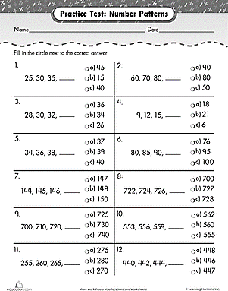

- Look at the following graph and answer the questions.
