MATH
GRADO 1°

TALLER DE VACACIONES

Answer the questions

- Noah had 12 books. He got 5 more books. How many books did Noah have in all?
- 17
- 16
- 15
- 13

- Bonnie found 8 rocks on her sidewalk and 7 rocks on her backyard. How many rocks did Bonnie find in all?
- 17
- 16
- 15
- 13

- Mariela collected 11 flowers. Then she found 3 more flowers. How many flowers did Mariela have in all?
- 17
- 16
- 15
- 13

- Fill in the missing numbers in the chart. Take into account which one goes before and after.
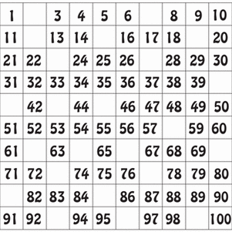

- Solve the following addition problems. Add the numbers.

- Solve the following subtraction problems.

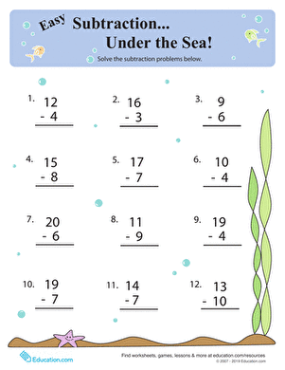

- Color according the difference of the subtraction.
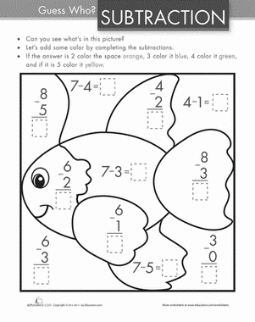

- Peter made 14 cookies. Then he made 5 more cookies. How many cookies did Peter have in all?
- 17
- 16
- 15
- 19

- Han has 9 comic books. He gave 3 away. How many comic books does he have left?
- 5
- 6
- 12
- 13

- Esther had 7 lollipops. She gave 2 away. How many lollipops does she have left?
- 5
- 6
- 12
- 13

- Let’s count backwards. Write the numbers from the highest to the smallest.
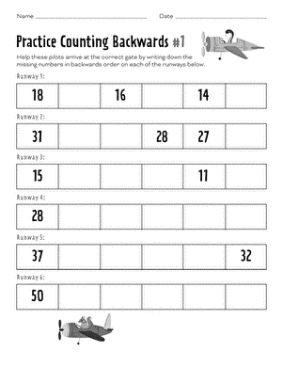

- Write each digit in the correct place value column.

